On the performance of confluent jets ventilation system in office space

T. Karimipanah¹ and B. Moshfegh^{1, 2}

¹ Division of Energy and Mechanical Engineering,
Department of Technology and Built Environment,
University of Gävle
S -801 76 Gävle, Sweden
² Division of Energy Systems,
Department of Management and Engineering,
Linköping University
S -581 83 Linköping, Sweden

Corresponding email: bahram.moshfegh@.liu.se

Abstract

The main objective of this study is to investigate the energy usage of four different air supply systems involving high- and low-level supplies for a ventilated room. The ventilation systems under consideration are mixing, displacement, impinging jet and confluent jets. The Renormalization Group (RNG) k-ε model has been used to predict indoor climate parameters such as the mean velocity, turbulence intensities, temperature and concentration fields. The numerical predictions are validated against earlier measurements with identical set-up.

The energy performance of the above-mentioned ventilation systems has been evaluated based on the fan power used which is related to the airflow rate required to perform the same indoor environment. The Air Distribution Index (ADI) is used to evaluate the indoor environment created in the room by the ventilation strategy being used. The results revealed that the mixing ventilation requires the highest fan power and the confluent jets ventilation needs the lowest fan power in order to achieve nearly the same value of ADI.

1. Introduction

During the past two decades, the world demand for primary energy has been doubled while during the same time the demand for electrical energy has tripled. In Sweden, energy demand in the built environment is a growing issue and the building sector accounts not only for nearly 40% of total energy use but also for 15% of the total CO₂ discharge.

The EU Commission states in the directive for energy efficiency in the built environment that the building sector has to decrease its use of energy to reduce CO₂ emissions. In Sweden, the Environmental Advisory Council have stated, within the framework of “Bygga Bo Dialogen”, (Build Housing Dialogue) that the demand for purchased energy in the building sector should decrease at least by 30% in 2025 compared to 2000 and energy use should be lower in 2010 than in 1995.

The connection between the increased CO₂ emissions and the use of energy is also a motive to render a more efficient energy usage, and lower the total energy demand. As a result, the need for energy conservation and reduction of electrical energy usage in the built environment is very high. Ventilation systems, thermal comfort and air quality within the built environment are important issues as they relate both to energy conservation and the health of the occupants.

The aim of this study is to fulfill the above-mentioned goals and is thus a step towards a sustainable building sector. This paper focuses on the energy usage of air supply processes for a ventilated office space involving high- and low-level supplies. The energy performance will be distinguished by the fan power consumption, which is related to the airflow rate, by achieving the same indoor environmental performance for each case. Four different ventilation systems are considered: wall displacement ventilation, confluent jets ventilation, impinging jet ventilation and a high-level mixing ventilation system. The ventilation performances of these systems are examined elsewhere [1-8].

The influence of temperature gradient on energy usage for mixing, displacement and confluent jets systems was numerically investigated by Vulle [9]. He used the IDA-Indoor Climate and Energy program for simulation of thermal comfort, indoor air quality and energy usage in buildings [10] in his calculations. He presented a potential energy saving of about 10-15% for confluent jets and displacement systems compared with a traditional mixing air supply system. In contrast to this paper, Vulle [9] does not discuss the relation between thermal comfort and air quality with energy usage.

2. Computational set-up and numerical procedure

The room under consideration, which is furnished like an office, is shown in Figure 1. The room has the dimensions 2.78×2.78×2.3 m. The boundary conditions for inlet velocity profile and turbulent intensity as well as the interior wall surface temperatures have been derived from the measurements by Cho et al. [3]. The supply air temperature is 18 ºC. The heat load consists of the heat gain at the exterior wall (55 W), the window (120 W) and the internal heat generation (100 W), corresponding to a cooling load of 35 W/m².

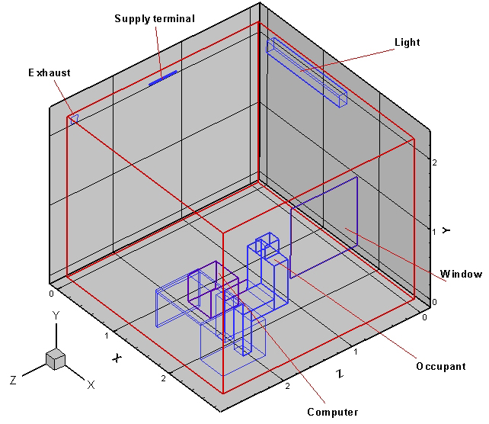
Figure 1 - A sketch of the office room.

VORTEX CFD code [11] is used for both grid generation and the numerical solution of the proposed problem. The generated mesh is a 3-D structured grid with 61×58×63 points (in x, y, z) for mixing, 58×44×51 for confluent jets, 60×60×65 for displacement and 67×60×69 for impinging jet, giving a total of about 222 894, 130 152, 234 000 and 277 380 cells respectively. Clustering the mesh towards the walls has been controlled in such a way that the employed wall-function treatment is properly applied. The Renormalization Group (RNG) k-ε model has been used to predict the turbulent behaviour of the flow within the room. The governing equations are solved using a segregated scheme. The equations for the momentum, energy, concentration, kinetic energy and turbulent dissipation rate are discretized spatially with a QUICK scheme. The pressure-velocity coupling algorithm SIMPLE is used to solve the continuity equation. The local criterion for numerical convergence, i.e. the maximum relative difference between two consecutive iterations for any local variable, is less than 10⁻³. To extend the degree of accuracy in the solution a calculation of the energy balance is also made.

3. Data reduction

To assess the effectiveness of a ventilation system, the effectiveness for heat removal (ε_{t}) and contaminant removal (ε_{c}) are used together with the predicted percentage of dissatisfied (PPD) for thermal comfort and percentage of dissatisfied (PD) for air quality. ε_{t} and ε_{c} are defined by [12]:

$ε_{t}=\frac{T_{o}−T_{i}}{T_{m}−T_{i}}$ (1)
$ε_{c}=\frac{C_{o}−C_{i}}{C_{m}−C_{i}}$ (2)

In Eqs. (1) and (2), T is temperature (ºC), C is the contaminant concentration (ppm), subscripts o, i and m denote outlet, inlet and mean value for the occupied zone (to a height of 1.8 m). ε_{t} is similar to a heat exchanger effectiveness and is a measure of the heat-removing ability of the system. ε_{c} is a measure of how effectively the contaminant is removed. The values for ε_{t} and ε_{c} are determined by heat and contaminant sources, the method of room air distribution, room characteristics, etc. However, high values do not always give a good indication of the thermal comfort and air quality in the occupied zone.

The expressions for the Percentage of Dissatisfied (PD) with the indoor air quality and the Predicted Percentage of Dissatisfied (PPD) with the thermal environment are given by Eqs. (3) and (4), see Fanger [13].

$\text{PD}=\text{395}⋅\text{exp}(−1\text{.}\text{83} {\overset{˙}{v}}^{0\text{.}\text{25}})$ (3)
$\text{PPD}=\text{100}−\text{95}\text{exp-}\left[0\text{.}\text{033353}{\left(\text{PMV}\right)}^{4}+0\text{.}\text{2179}{\left(\text{PMV}\right)}^{2}\right]$ (4)

Where $\overset{˙}{v}$ is the ventilation rate (l/s) and PMV is the Predicted Mean Vote as defined in ISO 7730 [14] and the recommended PPD limit for ideal thermal environment is 10%, corresponding to -0.5PMV0.5. Thus, low values for both indices guarantee a good indoor air quality and thermal comfort.

To examine the quality of a ventilation system a thermal comfort number, N_{t}, and an air quality number, N_{c}, may be found by combining relations (1) and (2) with PPD and PD respectively [12 and 15]:
$N_{t}=\frac{ε_{t}}{\text{PPD}}$ (5)
$N_{c}=\frac{ε_{c}}{\text{PD}}$ (6)

These two numbers can be combined into a single parameter which determines the effectiveness of an air distribution system in providing air quality and thermal comfort in the form of an Air Distribution Index (ADI), defined as [12]:

$\text{ADI}={\left(N_{t}×N_{c}\right)}^{0\text{.}5}$ (7)

In this investigation the above relation is used for comparing the ventilation performance of the ventilation systems.

The local age of air at any point in the room has been calculated using the following expressions:

${\bar{t}}_{p}=\frac{\int{C_{p}\left(t\right)}\text{dt}}{C\left(0\right)}$ (8)

The following relations between the flow rate, q, pressure difference, Δp, and the fan power, E, are used to evaluate the energy performance of the ventilation systems:

$Δp∝q^{2},E∝q^{3}$ (9)

4. Results

Comparing the indoor environmental performance of the studied ventilation systems with the same ADI index

Figure 2 shows a perspective view of the constant velocity magnitude in the occupied zone for the summer case with the iso-velocity 0.25 m/s for the mixing and confluent jets ventilation systems. The height of the occupied zone is 1.8 m and the occupied has the following distances from the surrounding surfaces: 0.30 m from each wall and 0.1 m above the floor. Figure 2 shows that the mixing system has one area, at the floor, with a velocity higher than 0.25 m/s. Figure 2 also reveals also that there is no significant problem for velocity distributions in the occupied zone for the confluent jets, except for a small part at the floor level under the supply device. The same effect has been also observed for the displacement system which creates a so-called near-zone. In the case with the impinging jet system, the air velocity is lower than 0.25 m/s in the whole occupied zone. This means that the impinging jet fulfils the standard criteria for velocities below 0.25 m/s in the occupied zone very well.

To relate the physical parameters of the indoor climate to the predicted comfort of the personnel, the PD (Percentage Dissatisfied due to draught) index has been used. The PD index is illustrated in Fig. 3 for the mixing and the confluent jets. The PD index is plotted at a plane which is 1.1 m over the floor level, i.e. the breathing zone.

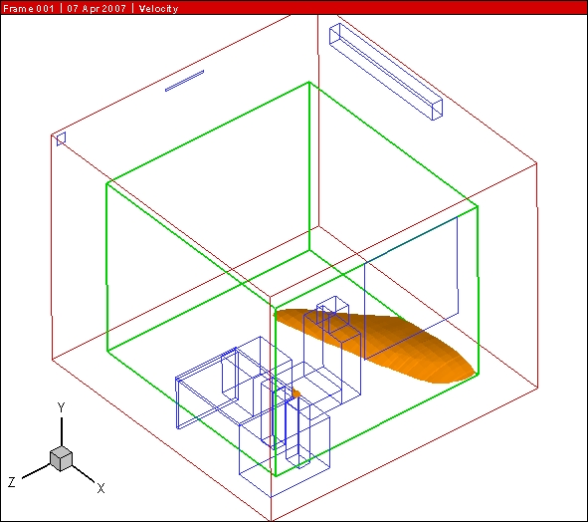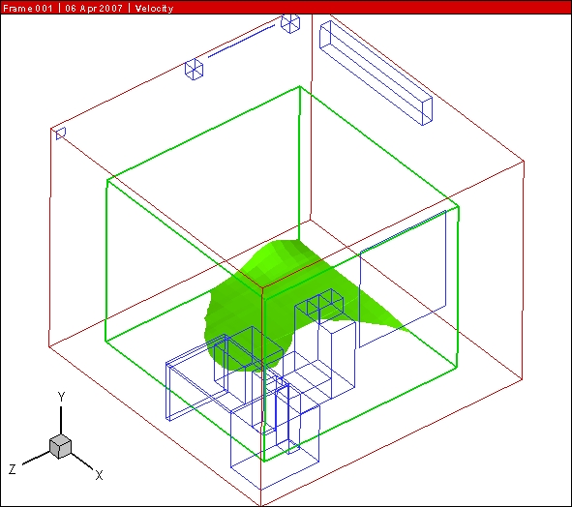
Figure 2. Iso-velocity for 0.25 m/s in occupied zone (mixing ventilation left and confluent jets ventilation right).

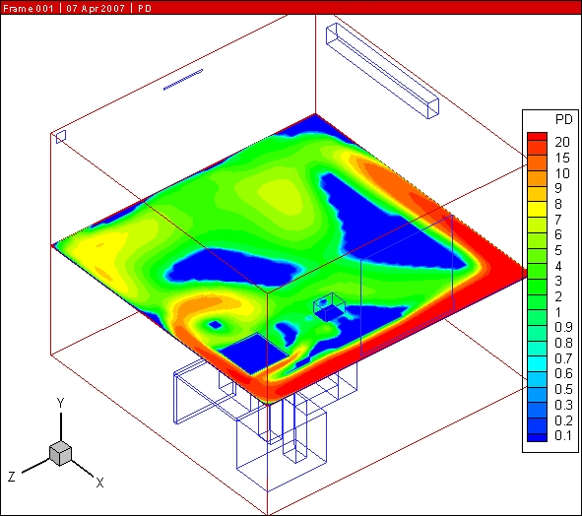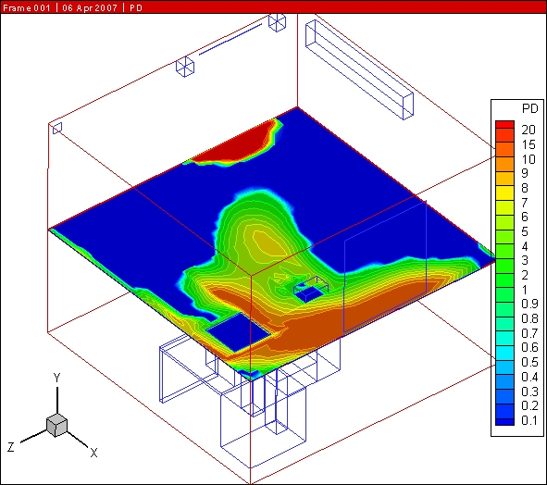
Figure 3. Percentage Dissatisfied due to draught at 1.1 m over the floor level (mixing ventilation left and confluent jets ventilation right).

As it is shown in Fig. 3, draughts may cause problems for the mixing system used in the present study. But the confluent jets system shows acceptable levels of PD for the occupant. One higher level is observed, far from the occupant, close to near-zone which is not remarkable in this case. The PD levels for the confluent jets are lower than those of the mixing system and are completely in the range of recommended standard values. The confluent jets behave like the displacement and the impinging jet ventilation systems.

Figure 4 shows predicted PPD values at 1.1 m over the floor level for the mixing and confluent jets systems. One can see from Fig. 4 that the highest levels of PPD are observed close to the occupant for the mixing system. It is worth mentioning that PPD values over 10% are not acceptable. This can be a result of very low ventilation efficiency of the mixing system which is theoretically up to 50%. This can be compared with the efficiencies of the displacement, confluent jets and impinging jet systems which are over 60% in many cases.

In the case of the confluent jets, as shown in Fig. 4, the highest levels of PPD are observed very close to the occupant and under the supply device. It is worth mentioning that in the dominant part of the room the PPD level is below or equal to 10%, which is the recommended standard value. Here one can see the benefits of CFD calculations in the pre-design stage. With the above observation it will be recommended to re-position the occupant into other risk-free zones in the room.

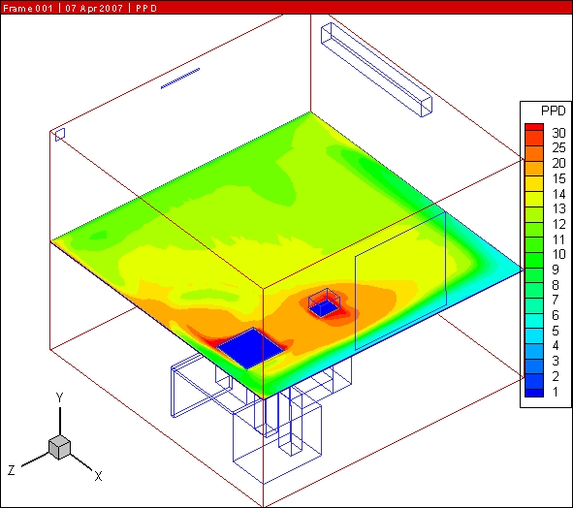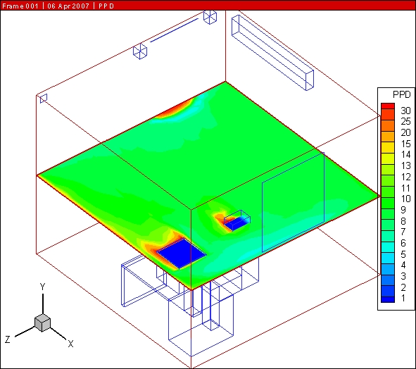
Figure 4. Predicted Percentage of Dissatisfied 1.1 m over the floor level (mixing ventilation left and confluent jets ventilation right).

Finally, when using PPD observations, it was found that the three systems—Confluent jets, impinging jet and displacement systems—behave similarly in the case of small office ventilation. In total, the predicted PPD values are almost acceptable. But for the market-dominated mixing systems this is not the case and should be avoided in terms of high energy usage and aspects of the occupants' health.

The temperature and velocity contours of the confluent jets ventilation system in the mid-plane of the room are shown in Fig. 5. The highest temperatures exist at ceiling level and the velocities are within the recommended standard values. Therefore the confluent jets system can combine the positive effects of the displacement system (stratification) and the mixing system (entrainment of the surrounding air into the jet). Another benefit of using a confluent jets system is that it can be used for both heating and cooling purposes.

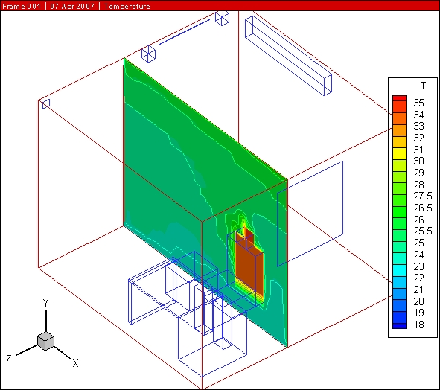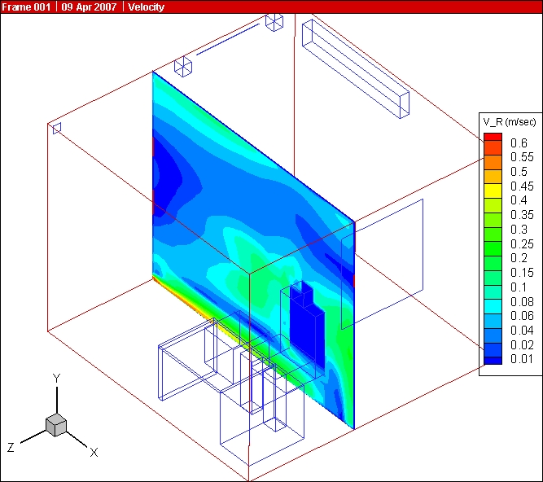
Figure 5. Temperature (left) and velocity (right) contours at mid-plane (ca z=1.6 m) for the confluent jets ventilation.
Comparing the energy usage for all ventilation systems performing the same ADI index

The min, mean and max values of PD and PPD in the occupied zone are summarized in Table 1. The results showed that the displacement, impinging jet and confluent jets supply systems provide nearly the same performance while the mixing ventilation has the highest PD and PPD values in the occupied zone, see also [16].

Table 1: PPD and PD values in the occupied zone for all ventilation systems with the same ADI index.
 | Mixing |  |  | Displacement |  |  | Impinging jet |  |  | Confluent jets
 | Min | Max | Mean | Min | Max | Mean | Min | Max | Mean | Min | Max | Mean
PPD (%) | 8.4 | 13.9 | 11.2 | 5.0 | 11.4 | 8.0 | 5.0 | 14.6 | 8.8 | 5.2 | 11.1 | 8.3
PD (%) | 2.2 | 12.9 | 11.7 | 1.0 | 6.8 | 4.5 | 1.4 | 5.0 | 3.6 | 1.2 | 10.0 | 6.9

The average values of ε_{t}, PPD, ε_{c}, PD and ADI in the whole room are summarized in Table 2. The results revealed that the highest thermal comfort number, N_{t}, and the air quality number, N_{c}, have been achieved by the confluent jets followed by the impinging jet and the displacement ventilation systems. The mixing ventilation has the lowest thermal comfort number, N_{t}.

Table 2: The average values of ε_{t}, PPD, ε_{c}, PD and ADI in the whole room for all ventilation systems.
 | Mixing | Displacement | Impinging jet | Confluent jets
ε_{t} (%) | 99 | 121 | 125 | 123
PPD (%) | 9.0 | 9.2 | 8.9 | 8.5
ε_{c} (%) | 118 | 118 | 120 | 121
PD (%) | 5.4 | 6.1 | 7.0 | 7.2
ADI [-] | 15.5 | 15.9 | 15.7 | 16.1

Using different air distribution strategies—see Table 3 and the Air Distribution Index (ADI) for comparison—one can see that there is no need for higher flow rate if one uses a better air supply method. According to Table 3, the confluent jets system gives the best ADI, i.e. 16.1, for the minimum flow rate of 0.025 m³/s that is considered.

To obtain nearly the same ADI index for a mixing system we need 1.8 times greater flow rate. Using relation (9), this gives 5.83 times higher energy usage. For the impinging jet system the flow rate is 1.4 times higher and demands 2.74 times more energy. The energy usage by the impinging jet system is almost half of the mixing system. The displacement system requires 1.1 times greater flow rate and 1.33 times higher energy usage compared to the confluent jets. Although the energy usage is lower than the other two systems, it is still higher than the confluent jets system.

Table 3: Comparison between the energy usage by the ventilation systems with the same ADI index.
 | ADI | Total flow rate | Energy usage
Mixing ventilation | 15.5 | 0.045 m³/s
Difference compared to confluent jets |  | 180% | 580%
Impinging jet ventilation | 15.7 | 0.035 m³/s
Difference compared to confluent jets |  | 140% | 270%
Displacement ventilation | 15.9 | 0.0275 m³/s
Difference compared to confluent jets |  | 110% | 130%
Confluent jets ventilation | 16.1 | 0.025 m³/s

5. Concluding remarks

The choice of air supply device has a major impact on energy usage by the ventilation system. The overall performance of the confluent jets air supply system is better than the displacement, impinging jet and mixing systems. To obtain the same Air Distribution Index for a mixing system 1.8 times greater flow rate is required and 5.83 times more energy is used. The displacement system uses 1.33 times and the impinging jet system uses 2.74 times the energy used by the confluent jets system, but they still perform better and use less energy than the traditional mixing system. The authors believe that for energy saving, new developments of low-level air supply systems are needed as well as a reduced reliance on traditional mixing systems which perform worse than low-level air supply systems.

References

1. Karimipanah T., Sandberg M. and H. B. Awbi, A Comparative Study of Different Air Distribution Systems in a Classroom. In Proc. of Roomvent 2000, Reading, England, 1013-1018 (2000).
2. Karimipanah T. and H. B. Awbi. Theoretical and Experimental Investigation of Impinging Jet Ventilation and Comparison with Wall Displacement Ventilation, Building and Environment 37 (2002) 1329-1342.
3. Cho Y., Awbi H. B and T. Karimipanah. A Comparison between Four Different Ventilation Systems". In Proc. of Roomvent 2002, Copenhagen, June (2002).
4. Karimipanah T., Awbi H. B., Sandberg M. and Blomqvist C. Investigation of air quality, comfort parameters and effectiveness for two floor-level air supply systems in classrooms. Building and Environment 42 (2007) 647-655.
5. Cehlin M., Moshfegh B. and Sandberg M., Measurements of air temperatures close to a low-velocity diffuser in displacement ventilation using infrared camera: parameter and error analysis. Energy and Buildings, 34 (2002) 687-698.
6. Cho YJ, Awbi H. B. and T. Karimipanah (2004), The characteristics of wall confluent jets for ventilated enclosures. In Proc. of Roomvent 2004, Coimbra, Portugal (2004).
7. Karimipanah T. and H. B. Awbi. Performance evaluation of two air distribution systems. Presented in The 5th International Conference on Ventilation for Automotive Industry, 11-12 June 2001, Stratford -Upon-Avon, United Kingdom (2001).
8. Awbi H. B. and T. Karimipanah. A comparison between three methods of low-level air supplies. In Proc. of Internat. Conference on Indoor Air Quality, Ventilation and Energy Conservation in Buildings (IAQVEC 2001), Chagsha, China, Vol. I, 311-316 (2001).
9. Vulle M. The impact of air temperature gradient on energy consumption, SIY Sisäilmatito Oy Finland, In Finish, (2006).
10. IDA Indoor Climate and Energy, http://www.equa.se/eng.ice.html
11. Awbi H. B. VORTEX: A computer code for airflow, heat transfer and concentration in enclosures, Version 3C and 4D-RNG, Reading, UK (2005).
12. Awbi H. B. Ventilation of Buildings. 2nd Ed., Taylor and Francis (E&FN Spon), (2003).
13. Fanger P.O. Thermal comfort. McGraw-Hill New York, (1972).
14. ISO/CEN 7730. Moderate thermal environments: Determination of PMV and PPD indices and specification of the conditions for thermal comfort (1994).
15. Awbi H. B. Energy Efficient Room Air Distribution, Renewable Energy 15 (1998) 293-299.
16. Karimipanah T., Awbi H. B. and Moshfegh B., On the energy consumption of high and low-level air suppliers. In Proc. of World Renewable Energy Congress IX and exhibition, Florence, Italy (2006).

